|  | INTERNATIONAL TELECOMMUNICATION UNION  **TELECOMMUNICATION** **STANDARDIZATION SECTOR**  STUDY PERIOD 2022-2024 | | **Focus Group on AI Native Networks** | |
| --- | --- | --- | --- | --- |
| **AINN-I-xx** | |
| **Original: English** | |
| **Question(s):** | | N/A | Virtual, TBD 2024 | |
| **INPUT DOCUMENT** | | | | |
| **Source:** | | *Omacs* | | |
| **Title:** | | *Omacs Squad - Report on* *ITU WTSA Hackathon 2024 – The Critical Drops* | | |
| **Contact:** | | Mr. Prudhvi | | E-mail: [email@gmail.com](mailto:email@gmail.com) |

| **Abstract:** | This document contains the submission report for team name “Omacs Squad” towards ITU WTSA Hackathon 2024 for use case *“The Critical Drops”.* |
| --- | --- |

## Use case introduction: **“The Critical Drops”**

Water scarcity is a significant challenge in Indian agriculture, particularly in states like Maharashtra, Rajasthan, and Tamil Nadu, AP. Efficient water management is crucial to ensure sustainable agricultural practices and food security.

In a small agricultural town in Andhra Pradesh, cutting-edge technology is used to balance the needs of both entertainment-loving residents and smart farming practices. Advanced network management ensures that all residents' entertainment needs and the critical demands of smart farming coexist smoothly. Thanks to predictive weather monitoring and adaptive resource allocation, Mr. Rao's fields are safeguarded from potential weather damage, all while the Reddy family enjoys a perfect movie night. This example highlights the power of technology to balance multiple priorities in real-time, enhancing both quality of life and agricultural productivity.

Consider the scene map below:

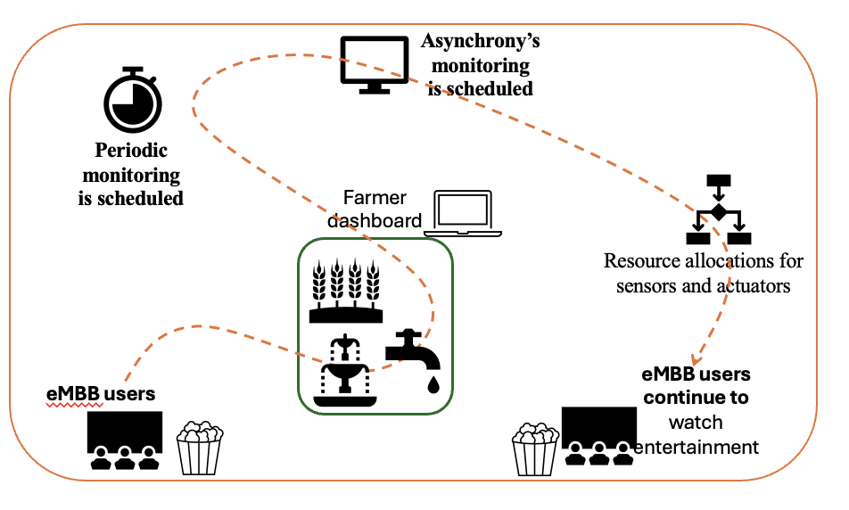

Phase 1: eMBB users are watching entertainment.

Phase 2: The local weather monitoring stations, equipped with advanced sensors, detect a sudden drop in atmospheric pressure and an increase in humidity, **predicting heavy rainfall within the next few hours**.

Phase 3: Periodic monitoring of nearby agricultural fields is scheduled.

Phase 4: OR Asynchronous monitoring of agricultural field may also be scheduled.

Phase 5: Sprinklers need to be shutdown and water disbursement needs to be regulated and Radio Resource allocations for sensors and actuators in the field **(Resource Pooling) need to be prioritized.**

Phase 6: After the monitoring and adjustments in the sensor and actuator configurations, eMBB users continue watching entertainment.

Clause-2: use case requirements

Clause-3: PS1: pipeline design

* AI /ML Concept used is weather prediction and resource requirement prediction.

Clause-4: PS2: xApp design

* Open RAN concept used is adaptive pre-scheduling parameters configuration by dynamically adjusting the scheduling

Clause-5: Relation to Standards.

Clause-6: Code submission details

Clause-7: Self-Testing results

_________________